1. Create below table using html and CSS (Solution : Table1.html)
2. 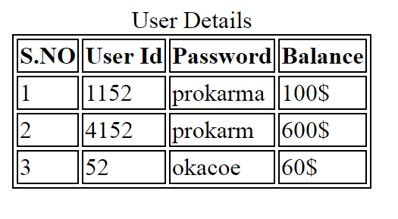
3. Dxvx
4. Vdv
5. Sdfsdf
6. Sdfsdf
7. Sdf
8. Sdfsdfds
9. Sddfsdfsd